Year 9 ICT
HTML
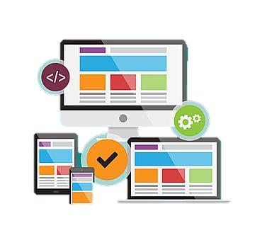
Name:
Class:

What is HTML?
HTML stands for hypertext markup language. It is used to create websites on the world wide web. Each website contains a number of web pages, each with a unique address called a URL.
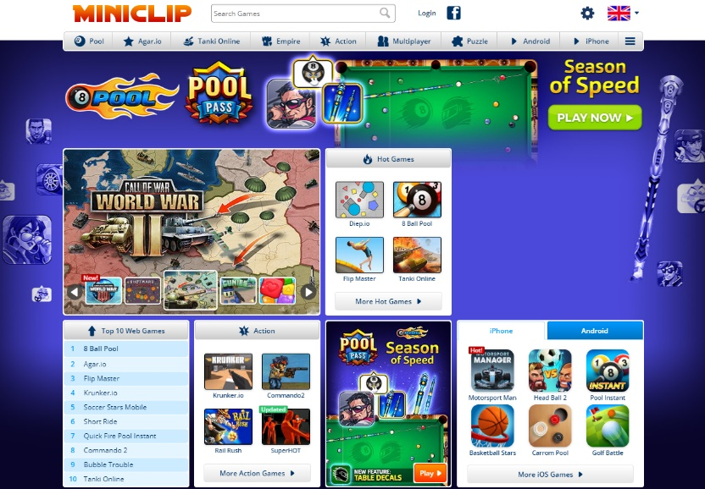
All websites use the same instructions in order to create these webpages and have them always look the same on every internet browser (Google Chrome, Mozilla Firefox, Safari etc) you use. These instructions come in the form of tags. Each tag has its own purpose and use on the webpage, and yet we can create so many different looking web pages with these tags!

The latest version of this language is HTML5.

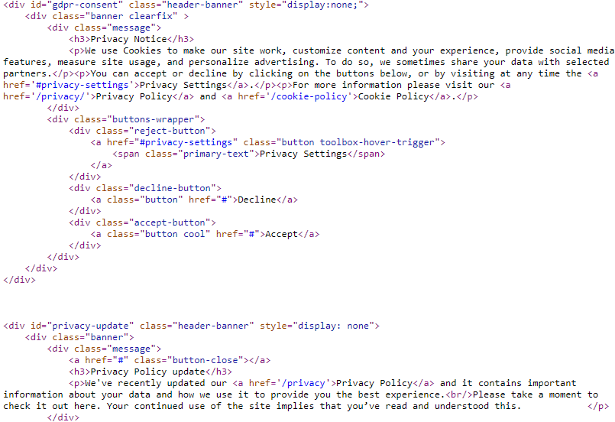
The people who make websites are called web developers. They don’t create Microsoft Word Documents to create websites, or even WIX web builders. A website like Miniclip actually uses these tags – even if you don’t see them when viewing the webpage.

What is actually happening when you go to a website is that your browser is loading a text file with these tags. Your internet browser then ‘reads’ these tags and creates the shapes, images and buttons.

What was the first website?

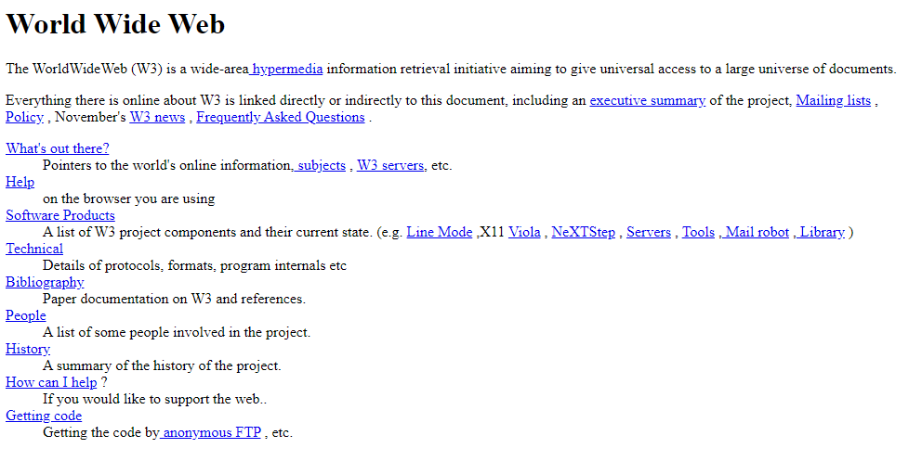The first website was made on the 6th August 1991 by a famous computer scientist called Tim Berners-Lee. He was famous in creating the bricks that form the world wide web having seen there was a huge demand for automatically sharing information between universities around the world. He started working on the world wide web project in 1989 where he worked on HTTP and HTML specifications to standardise how these webpages could be shared.
He went on to found the World Wide Web Consortium (W3C) in 1994 which really boosted the use of the web to what we see today in the form of social media, e-commerce and streaming websites.

Not all websites are created equally
There are many ways websites differ, often through the different fonts, colours and interactive features available. When developing websites, it is vital you don’t get carried away with colours and fonts – or you could find that your own website runs into a lot of issues, including:
- Colour schemes/too many colours
- Layout is hard to navigate
- Text is difficult to read
- Eyes drawn all over the place – no order to where you should look!
- Pictures aren’t clear (pixelated)
- No alignment to text/textboxes

Navigation
Navigation is a key design aspect when you are designing a website, which should be easy to use for your target audience. Research shows that users will not use a website if it is difficult to navigate around, meaning you should focus on the Consistency in menus and buttons, with the menu being the same on every page of the website and clearly identifiable.
The buttons (hyperlinks) should be clearly named (The user should know exactly what to expect if button x is pressed). If you decide to use rollover effects on your buttons, you can increase interactivity – so long as they don’t distract the user!

Key Term | Definition
World Wide Web | A huge collection of websites that we can access through the internet. Holds webpages and web resources (such as images and videos) and can be accessed over the internet. It is the software hosted on the internet.
Internet | A global network consisting of interconnected computers. It is the hardware that communicates with one another.
Web Pages | Each website has multiple screens known as web pages.
Hyperlinks | We can navigate and click between webpages using hyperlinks. You click on a word or image to take you to another web page
Internet Browser | This is a program that reads and displays HTML documents. It does not display the HTML tags but uses them to display the document.

Is this not really complicated?
It’s actually not as complicated as you think it is! You just need to remember:
- ‘Tags’ are used throughout a html document
- These tags use angled brackets < and >
- Tags nearly almost always come in pairs. If you open a tag, then you must also close it. The closing tag also is denoted by a forward slash /
- Tags can have attributes to alter their appearance and functions.
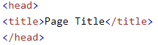
- Tags can be embedded inside each other. For example:
Closing the title Tag
Opening the Head tag
The title tag is inside the head tag
Closing the head Tag

How do websites know what to display?
HTML tags label piece of content such as ‘heading’, ‘paragraph’ and ‘table’
Browsers to not display these tags directly, but use these to render content on screen
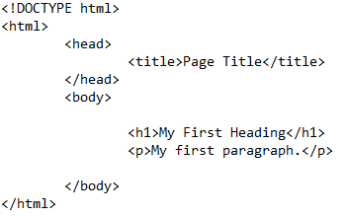
Here is a very simple HTML file.

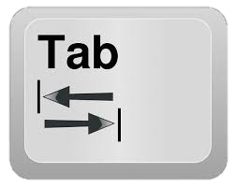
Note we use the tab key to align embedded content.
If a tag is ‘inside’ another, it should be tabbed in.

This keeps it very clear what is inside and what isn’t inside a tag.
In the example above, you can see there is a h1 and a p tag inside the body tag.
This is because you can see the h1 tag both starts and end inside the body tag.
Key Tags used in this example:
- The <!DOCTYPE html> declaration defines the document to be a html5 (so web browsers know this document is a website).
- The <html> element is the root element – EVERY TAG needs to be inside these (this tells the browser to read this as the website contents)!
- <head> contains meta information about the document (don’t worry too much what the word meta means. It basically tells the browser things, but doesn’t have any content that actually appears to the user of the website).
- <title> specifies a title for the document (what appears in the tab in the browser)
- The <body> element contains the visible content of the page (what appears to the user)
- <h1> is ‘heading 1’ tag, which is used for a large heading on screen. There are other headings available also, such as <h2>, <h3>, etc.
- The <p> element defines a ‘paragraph’ (so if you wanted to display a paragraph of text).
The starting tag (AKA opening tag) goes here and is surrounded in angled brackets, < and >
To end a tag, you write it just like the starting tag, but with a forward slash, /, inserted before the tag name.

<tagname>Content to be displayed can go here…</tagname>

Anything you want to actually display on screen goes here, between the opening and closing tags

Page structure
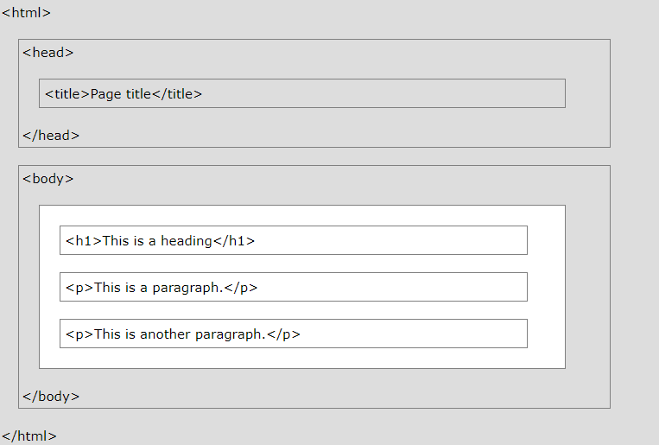

- Only the part in White section is actually displayed by the browser.
- It is very important, however, that the tags in the grey area are still present as they are used by the browser.

Tags we can use
Tag Name | Example | Use
Headings | <h1>This is my heading</h1>  <h2>This is a slightly smaller heading</h2>  <h3>This is smaller again</h3> | So, usually at the top of a page we would have a nice big title – something prominent. It’s the same for websites
Paragraphs | <p>This is a paragraph tag, which can contain lots of text</p> | Paragraphs are often used in web pages, just like in standard texts.
Hyperlinks | <a href=“https://www.google.com”>Click Here to go to Google</a> | HTML links, or hyperlinks, are defined using the anchor <a> tag.  They use an attribute within the element. This goes inside the opening tag.
Images | <img src=“C:/myimage.jpg” alt=“My Logo” width=“64” height=“32” /> | It’s very important to have images in websites – they are both informative and engaging, ensuring visitors are attracted to the website.  This is one that doesn’t have a closing tag – it is known as a self-closing tag as no text is actually placed on screen here. We use /> to end this tag instead.  Instead it has a few attributes to tell the browser what to display
Ordered Lists | <ol>  <li>Apples</li>  <li>Oranges</li>  <li>Bananas</li>  </ol> | Ordered lists use numbers instead of bullet points.  They have <li> tags inside, which stand for list item. You can have multiple list items inside an ol tag.
Unordered Lists | <ul>  <li>Apples</li>  <li>Oranges</li>  <li>Bananas</li>  </ul> | Just like the ordered list, however instead this tag uses bullet points.  The same li tags are used to make new bullet points.
POINTS TO REMEMBER
An HTML element is defined by a start tag, some content, and an end tag.
A start tag may also contain attributes that act as instructions for the browser
Some tags, like the image <img> tag, do not have a closing tag and are called self-closing.
Tags can be embedded inside each other
All content being displayed on the webpage must be embedded inside the body tag.
  - Some attributes must be included when using certain tags (such as a href attribute within a hyperlink, <a> tag.

Styling Tags
Styling is the reason we have so many websites that look completely different to one another, even if we are using the same tags.
Styling allows us to change colours, fonts, add shadows and in some designs, add hover effects and create animations! Lets keep it simple for now and let’s just talk about adding styling into your website.
There are 3 main ways of adding styling to our tags (so they don’t look boring):
- Use inline styling
- Use a <style> tag within the head of the document
- Use an external style sheet
Inline styling is very easy to add for a single page website, but is not recommended for large projects.
We can use a style tag at the beginning, which is fine for small projects but will only apply to a single webpage at a time. This means to style different webpages, you’ll have to copy your styling code across, which isn’t recommended.
The last option of using an external style sheet is great, as it can be used across different web pages and if you wanted to update a style, you would only have to change it in one place. However, it takes a little bit of time to understand how these styles work and how to add it to a page.

The style Tag (Option 2)
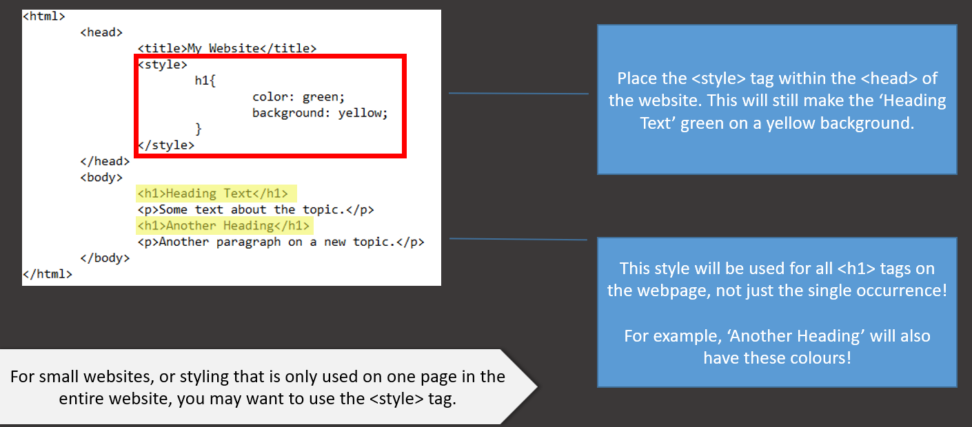
Option 3: External CSS
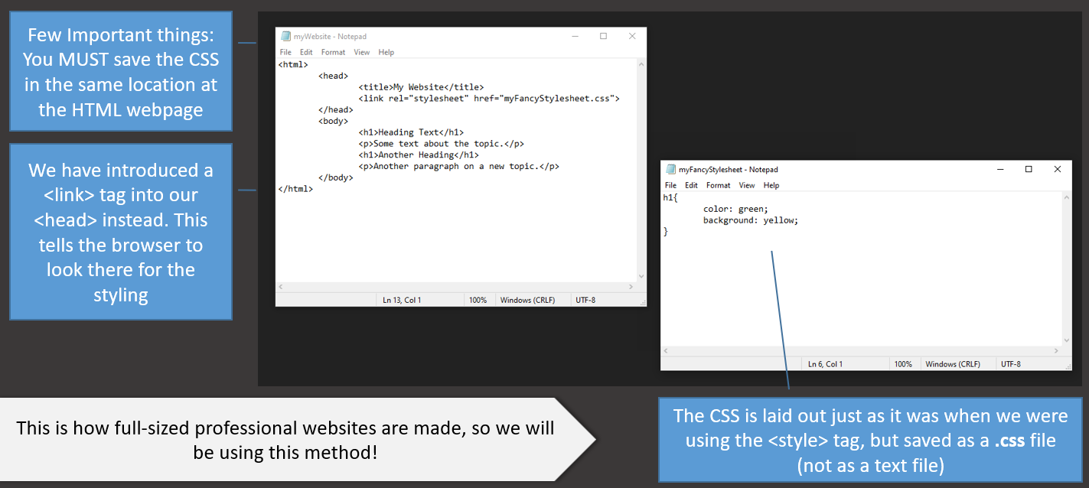

CSS Selectors
CSS Selectors are a way of choosing which tags you want to style.
For example, we used a tag selector to choose/select all the <h1> tags.
h1{
color: red;
}
If we wanted to select all <h2> tags instead, we could change this.
h2{
color: red;
}
Or we could have more than one selector like this:
h1, h2{
color: red;
}
We can add an external stylesheet to our website using a link in our head of a website:
<link rel=”stylesheet” href= “myStylesheetName.css”>

